**TEST REPORT**

The following test results were deduced on a computer with a clock speed of 2.00 GHz.

The following parameters were tested:

* Execution Time
* Number of nodes expanded
* Number of moves made
* Memory Usage

The above parameters were tested against:

* Iterative Deepening search
* A* search with Manhattan distance heuristic
* A* search with a heuristic which is a variant of pagoda function
* A* search with a random heuristic

A brief description of the algorithms as applied to this game:

Iterative Deepening:

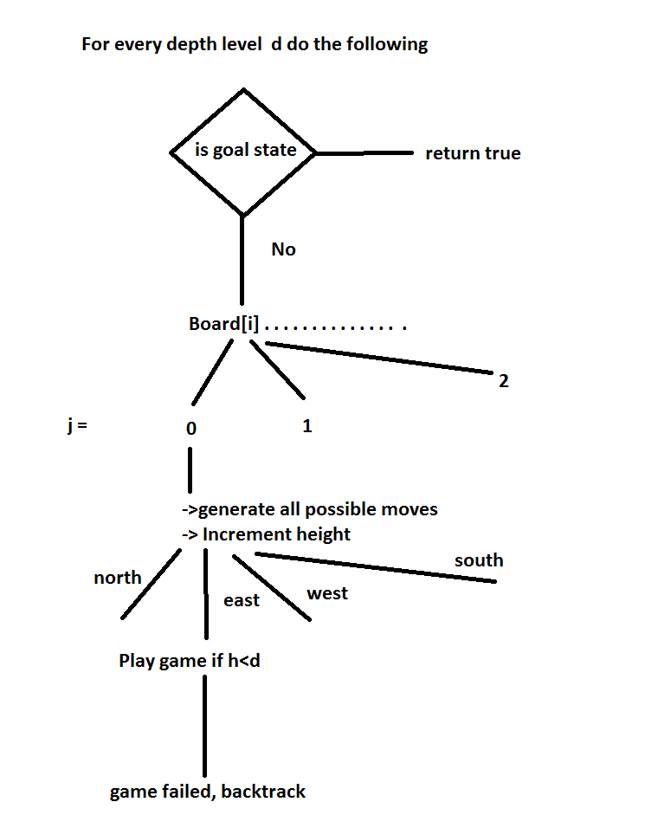

* A* search heuristic

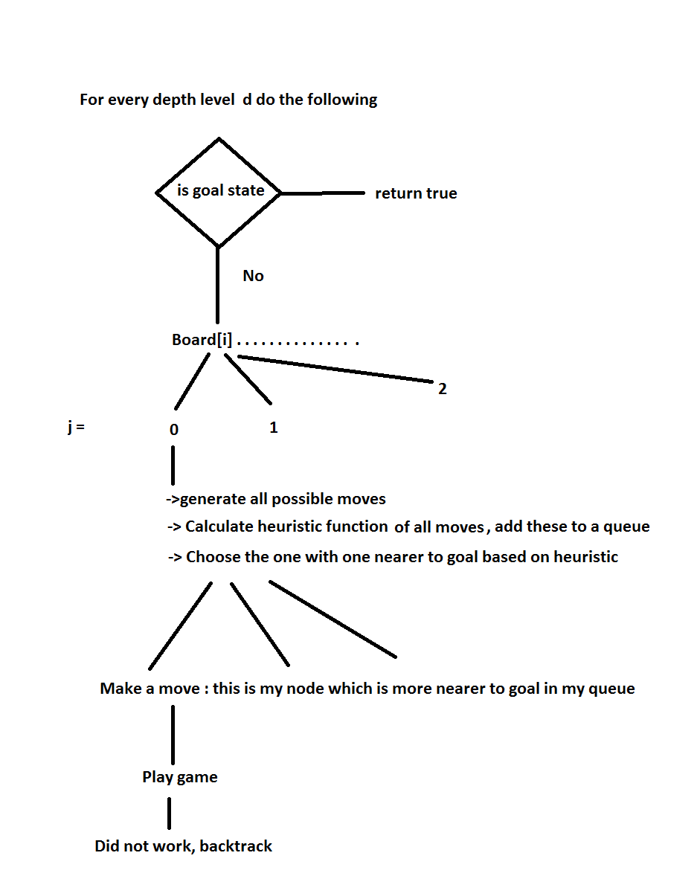

Three heuristics were considered:

* Sum of the distances of each peg from the centre.
* Assigning a value to all board positions, to determine if a particular board is favorable [1]or not. ( this is not my own idea. I picked this up by learning about pagoda functions and other papers)
* Assigning a random value to moves in proportion to number of moves. Though this heuristic is not consistent or admissible, it always performs better than DFS.
* The order of applying the heuristics also is tested :
* The DFS way:

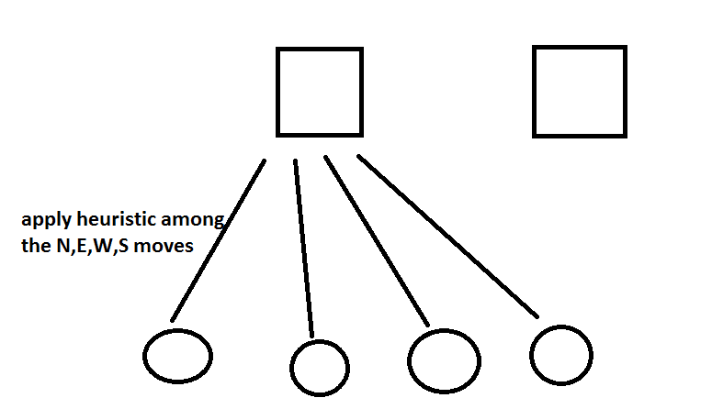

* The BFS way:

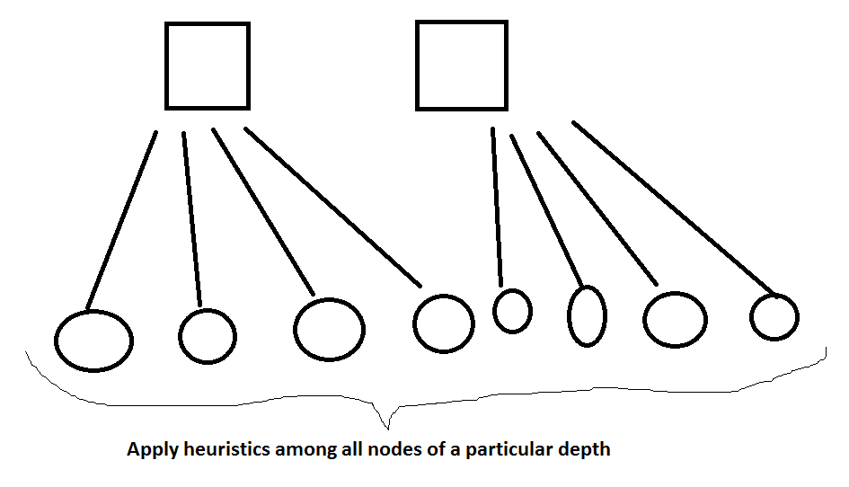

* Minimal pruning has been performed. The failed state nodes are transposed and added to a hashmap. If we encounter a similar node, we discard it.
* Memory is maintained minimal, by backtracking on the same board.[2]

The following test cases were considered[3]:

|  |  |  |
| --- | --- | --- |
| BOARD | Number of Pegs |  |
| Config1 | 4 | <--000--,--0X0--,0X00000,00X0000,00X0000,--000--,--000--> |
| Config2 | 8 | <--000--,--000--,XXXX000,XXX0000,X000000,--000--,--000--> |
| Cross | 6 | <--000--,--0X0--,00XXX00,000X000,000X000,--000--,--000--> |
| Plus | 8 | <--000--,--0X0--,000X000,0XXXXX0,000X000,--0X0--,--000--> |
| Pyramid | 16 | <--000--,--0X0--,00XXX00,0XXXXX0,XXXXXXX,--000--,--000--> |
| Fireplace | 11 | <--XXX--,--XXX--,00XXX00,00X0X00,0000000,--000--,--000--> |
| complete | 32 | <--XXX--,--XXX--,XXXXXXX,XXX0XXX,XXXXXXX,--XXX--,--XXX--> |
| NoSolution | 22 | <--XXX--,--000--,XXXXXXX,X00000X,XXXXXXX,--000--,--XXX--> |
| No Solution | 33 | <--XXX--,--XXX--,XXXXXXX,XXXXXXX,XXXXXXX,--XXX--,--XXX--> |

**Observations of the tests performed:**

* **The heuristics applied perform better for more number of pegs**
* **BFS way of applying the heuristic performs better than DFS way of applying the heuristic**
* **Random heuristic sometimes performs better than no heuristics**
* **The pagoda variant performs better than the Manhattan distance heuristic.**
* **The direction of the moves made ( north, east, west, south) also matter. The goal positions are likely to be hit earlier.**

|  |  |  |  |  |  |  |  |
| --- | --- | --- | --- | --- | --- | --- | --- |
| Board Config | Execution Time( in seconds) | | | | | | |
|  | Iterative Deepening | A* Heuristic (Manhattan distance) | | A* (pagoda variant) | | A*( a random heuristic) | |
|  |  | DFS | BFS | DFS | BFS | DFS | BFS |
| Config1 | 0.0019 | 0.01 | 0.001 | 0.01 | 0.001 | 0.01 | 0 |
| Config2 | 0.03 | 0.03 | 0.03 | 0.03 | 0.003 | 0.018 | 0.016 |
| Cross | 0.04 | 0.0019 | 0.002 | 0.002 | 0.002 | 0.001 | 0.02 |
| Plus | 0.66 | 0.012 | 0.005 | 0.008 | 0.003 | 0.005 | 0.03 |
| Pyramid | >1 hour | 0.053 | 9.3 | 0.837 | 0.41 | 0.002 | 0.04 |
| Fireplace | 1.87 seconds | 0.67 | 1.08 | 0.631 | 0.11 | 0.36 | 0.038 |
| complete | >1 hour | >1hour | >1hour | 18 min | 15 min | 1.44 | >1 hour |
| No Solution | 0 | 0 | 0 | 0 | 0 | 0 | 0 |
| No Solution | 0 | 0 | 0 | 0 | 0 | 0 | 0 |
|  | Number Of Nodes Expanded | | | | | | |
|  | Iterative Deepening | A* Heuristic (Manhattan distance) | | A* (pagoda variant) | | A*( a random heuristic) | |
|  |  | DFS | BFS | DFS | BFS | DFS | BFS |
| Config1 | 10 | 4 | 3 | 4 | 4 | 4 | 6 |
| Config2 | 963 | 242 | 229 | 242 | 13 | 242 | 221 |
| Cross | 83 | 9 | 6 | 9 | 6 | 9 | 17 |
| Plus | 1761 | 53 | 22 | 53 | 9 | 56 | 24 |
| Pyramid |  | 5771 | 64858 | 5771 | 2500 | 23 | 464 |
| Fireplace | 51913 | 4341 | 7927 | 4341 | 766 | 4991 | 457 |
| complete | --a lot-- |  | 8,97,345 | 7022154 | 5,34,564 | 18629 | -- |
| No Solution | 0 | 0 | 0 | 0 | 0 | 0 | 0 |
| No Solution | 0 | 0 | 0 | 0 | 0 | 0 | 0 |

|  |  |  |  |  |  |  |
| --- | --- | --- | --- | --- | --- | --- |
| Number of Moves Made | | | | | | |
| Iterative Deepening | A* Heuristic (Manhattan distance) | | A* (pagoda variant) | | A*( a random heuristic) | |
|  | DFS | BFS | DFS | BFS | DFS | BFS |
| 17 | 5 | 3 | 5 | 5 | 5 | 9 |
| 1919 | 477 | 451 | 477 | 19 | 477 | 435 |
| 161 | 13 | 7 | 13 | 7 | 13 | 29 |
| 3514 | 98 | 36 | 98 | 10 | 104 | 40 |
|  | 11527 | 129701 | 11527 | 4985 | 31 | 913 |
| 103816 | 8672 | 14584 | 8672 | 1522 | 9972 | 907 |
| --- |  | 16342982 | 14044277 | 10453232 | 37227 |  |
| 0 | 0 | 0 | 0 | 0 | 0 | 0 |
| 0 | 0 | 0 | 0 | 0 | 0 | 0 |

|  |  |  |  |  |  |  |  |
| --- | --- | --- | --- | --- | --- | --- | --- |
| Board Config | Memory consumed in Bytes | | | | | | |
|  | Iterative Deepening | A* Heuristic (Manhattan distance) | | A* (pagoda variant) | | A*( a random heuristic) | |
|  |  | DFS | BFS | DFS | BFS | DFS | BFS |
| Config1 | 568 | 184 | 184 | 184 | 184 | 184 | 184 |
| Config2 | 1080 | 184 | 184 | 184 | 184 | 184 | 184 |
| Cross | 824 | 184 | 184 | 184 | 184 | 184 | 184 |
| Plus | 1208 | 184 | 184 | 184 | 184 | 184 | 184 |
| Pyramid |  | 184 | 184 | 184 | 184 | 184 | 184 |
| Fireplace | 1464 | 184 | 184 | 184 | 184 | 184 | 184 |
| complete |  | 184 | 184 | 184 | 184 | 184 | 184 |
| No Solution | 2944 | 128 | 128 | 128 | 128 | 128 | 128 |
| No Solution | 4352 | 128 | 128 | 128 | 128 | 128 | 128 |

References :

* http://www.jaapsch.net/puzzles/pegsolit.htm

* <http://www.delphiforfun.org/programs/PegSolitaire.htm>

* The following books and research papers ideas were used while formulating the solution of this project.





1. Refer to “winning ways in mathematical plays”
2. Refer to DFS solves Peg Solitaire
3. Few test cases were picked from <http://www.delphiforfun.org/programs/PegSolitaire.htm>